Module 1 (Set 1 code)
Logistic Regression

1) Logistic regression is a simple form of a neural network that classifies data categorically. Logistic regression takes an input, passes it through a function called sigmoid function then returns an output of probability between 0 and 1
Neural networks are somewhat related to logistic regression. Basically, we can think of logistic regression as a one layer neural network.

2) pima[np.where(pima[:,0]>8),0] = 8
In this we are restricting maximum pregnancy to 8 and Pregnancy-more than 8 is be taken as 8.
pima[np.where(pima[:,7]<=30),7] = 1
here we are quantizing the age in 5 buckets.

3) Using Glucose and BMI features as input features:
[[1.1345644 0.62512448]]
Misclassified samples: 59
Accuracy: 0.74

Using Triceps Skin Fold Thickness and 2-Hour serum insulin as input features:
[[0.00243415 0.31672215]]
Misclassified samples: 84
Accuracy: 0.64
Instead of Glucose and BMI features, if we use Triceps Skin Fold Thickness and 2-Hour serum insulin as input features to train the model we can see there is decrease in the in the accuracy.
The classifier is unable to classify correctly.

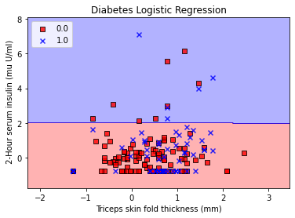
Almost all the points falls under single region which leads to miss classification and the clisssifier is almost horizontal.

4) If we use all the features instead of only 2 features accuracy increases, although accuracy increases we’ll not be able to plot output as plotting of more than 2 features requires multi dimensions which is very difficult to visualize.

